

**Pearson**

**Higher Nationals in**

**Computing**

PEARSON SET ASSIGNMENT

UNIT 13: Computing Research Project

**Project Proposal**

**Project Proposal Report**

|  |  |  |  |  |  |  |  |
| --- | --- | --- | --- | --- | --- | --- | --- |
| **Course Title** | **Pearson Higher Nationals in Computing** | | | | | | |
| **Unit** | **Unit 13 - Computing Research Project** | | | | | | |
| **Project Title** | **SMART INTELLIGENCE SUPERMARKET TROLLEY** | | | | | | |
| **Student Name** | **Farha Imthiyaz** | | | | | | |
| **Centre No** |  | | | **Edexcel No** | | **KJ46494** | |
| **Contact No** | **0729157405** | | | **Email** | | **farhaimthifari123@gmail.com** | |
| **I certify that the given project proposal is appropriate and my own work to the best of my knowledge and I understand that plagiarism** is strictly prohibited and **may lead for penalty.** | | | | | | | |
| **Students Signature** |  | | | **Date** | | | **2019/02/05** |
| **Comments** | | | | | | | |
| **Project Supervisor** | | **Mr. Anis Saboordeen** | | | | | |
| **Date** | |  | **Signature** | |  | | |
| **Project Coordinator** | | **Mr. Anis Saboordeen** | | | | | |
| **Date** | |  | **Signature** | |  | | |

**Ethical Consideration Approval Form**

|  |  |  |  |
| --- | --- | --- | --- |
| **Section One: Basic details** | | | |
| Project title: | **SMART INTELLIGENCE SUPERMARKET TROLLEY** | | |
| Student name: | **Farha Imthiyaz** | | |
| Student number: | **CSD/17/57/05** | | |
| Intended research start date: | 2019/ 01/ 11 | end date: | 2019/ 04/ 10 |

|  |  |  |
| --- | --- | --- |
| **Section Two: Project summary** | | |
| Please select all research methods that you plan to use as part of your project: | | |
| Interviews | ☑ |  |
| Questionnaires | ☑ |  |
| Observations | □ |  |
| Use of personal records | ☑ |  |
| Data analysis | ☑ |  |
| Action research | ☑ |  |
| Focus groups | □ |  |
| Other (please specify):online samples, face to face interview, Character interviews | | |

|  |  |  |  |
| --- | --- | --- | --- |
| **Section Three: Participants** | | | |
| Please answer the following questions, giving full details where necessary. | | | |
| Will your research involve human participants? **Yes** | | | |
| Who are the participants? Tick all that apply: | | | |
| Children aged 12–16: ☑ | Young people aged 17–18: ☑ | Adults: ☑ | |
| How will participants be recruited (identified and approached)?  Our Lecturer Mr. Anis Saboordeen involves to this project and he guided and gave ideas to this project. I got information for this project from main methodology is questionnaire. So, I sent this questionnaire to my friends and known people. So, they also helped in my information gathering stage in my research. | | | |
| Describe the processes you will use to inform participants about what you are doing   * From my explanation and Presentation of my project * From the questionnaire which I gave to collect information for my project. * At the end, From the Poster. * From see the Implemented Artifact. | | | |
| How will you obtain consent from participants? Will this be written? How will it be made clear to participants that they may withdraw consent to participate at any time?  When I am doing project our lecturer helps in my project implemented phase, information gathering phase and all the phases in project. But, Other people whom they gave support for my project information gathering phase. | | | |
| **Studies involving questionnaires:** | | | |
| Will participants be given the option of omitting questions they do not wishto answer? | | Yes □ | No ☑ |
| If No please explain why below and ensure that you cover any ethical issues arising from this:  I didn’t cover any ethical issues arising from this project. | | | |
| **Studies involving observation:** | | | |
| Confirm whether participants will be asked for their informed consent to be observed. | | Yes □ | No ☑ |
| Will you debrief participants at the end of their participation (i.e. give them a brief explanation of the study)? | | Yes ☑ | No □ |
| Will participants be given information about the findings of your study? (This could be a brief summary of your findings in general.) | | Yes ☑ | No □ |

|  |  |  |  |  |
| --- | --- | --- | --- | --- |
| **Section Four: Data storage and security** | | | | |
| Confirm that all personal data will be stored and processed in compliance with the Data Protection Act (1998): | | | Yes ☑ | No □ |
|  | | | | |
| Who will have access to the data and personal information?  Our lecturer and I have access to the data and personal information. | | | | |
| **During the research:** | | | | |
| Where will the data be stored? | In my Laptop | Google Drive | Email | |
| Will mobile devices (such as USB storage and laptops) be used? | | | Yes ☑ | No □ |
| If yes, please provide further details:  I use my laptop storage to store my data. | | | | |
| **After the research:** |  |  |  | |
| Where will the data be stored? | In my Laptop | Google Drive | Email | |
| How long will the data and records be kept for and in what format? | Zip format | Word format |  | |
| Will data be kept for use by other researchers? | | | Yes □ | No ☑ |
| If yes, please provide further details in section 5 | | | | |

|  |
| --- |
| **Section Five: Ethical issues** |
| Are there any particular features of your proposed work which may raise ethical concerns? If so, please outline how you will deal with these:  Our proposed work which maybe raise ethical concerns. I will be restrict to read my project documentation or Artifact with my permission. |
| It is important that you demonstrate your awareness of potential risks that may arise as a result of your research. Please consider/address all issues that may apply. Ethical concerns may include, but are not limited to the following:  With my permission only anyone can read or get idea from my project. With the questionnaire who gave me information for project if they are interested in my project they can be Potentially vulnerable participants. In this project literature survey, planning in Gantt chart and methodology which I used for this project are Sensitive topics. We will store our project data and information in my laptop, Google drive and email in during and after the research. When I share my project with anyone I will encrypt the Project data and information. From my findings that this project is very much demanded, focus on business and successful project. |

|  |  |  |
| --- | --- | --- |
| **Section Six: Declaration** | | |
| I have read, understood and will abide by BCASResearch Ethics Policy: | Yes ☑ | No □ |
| I have discussed the ethical issues relating to my research with my Unit Tutor: | Yes ☑ | No □ |
| **I confirm that to the best of my knowledge:**  The above information is correct and that this is a full description of the ethics issues that may arise in the course of my research.  Name: .......Farha Imthiyaz...............................................................................................................................................................................................................................................  Date: ..................**2019/02/05.................................................................** | | |

**Please submit your completed form via: Online Portal / Email**

**TABLE OF CONTENT**

**1. Statement of Project Details 8**

**1.1 Project Title 8**

**1.2 Academic Question 8**

**1.3 Aims (provide a list) 9**

**1.4 Objectives (provide a list) 9**

**1.5 Proposed Artefact to be developed in brief 9**

**2. Main Section of the Report 9**

**2.1 Introduction 9**

**2.2 Initial Research into sources of information (Literature Survey) 10**

**2.2.1 MEPITS 10**

**2.2.2 SATHI (PERSONAL ASSISTANT) 11**

**2.2.3 iCart (The Smart Shopping Cart) 12**

**2.2.4 AMAZON GO 14**

**2.2.5 indolytics technology 15**

**2.2.6 Modern-Expo Group (Self-Checkout on the Go (Smart Shopping Cart)) 16**

**2.2.7 Flavio Bernardo 17**

**2.2.8 Grocer Augmented Shopping (European Project) 18**

**2.3 Research approach and methodologies 21**

**2.3.1 Quantitative research methods 21**

**I. Online surveys 22**

**2.3.2 Qualitative research methods 25**

**2.4 Artefact (proposed) 26**

**2.5 Tools and Techniques: 27**

**2.5.1 Tools 27**

**2.5.2 Techniques 27**

**2.6 Plan/Schedule 28**

**2.6.1 Gantt chart 28**

**2.6.2 Work break structure 28**

**2.6.3 Active network diagram 30**

**2.6.4 Time plan with Resources 30**

**2.7 Cost Analysis 31**

**2.8 References and Bibliography 32**

**3 Research Ethics Approval Form 33**

# Statement of Project Details

Provide a statement of the project details only.

## Project Title

**SMART INTELLIGENCE SUPERMARKET TROLLEY**

## Academic Question

|  |  |
| --- | --- |
| What is this Project about? | This is a project of implementing a smart trolley using with IOT (Internet Of Things) and AI (Artificial Intelligent). |
| Why is this project for? | * This project is we will implement as a final project in HND. * I choose this smart trolley because after doing many final projects not use in practically. Because we need to control large area public. That is not practical. But, If we focus small area usable project meant that will be easily use by public and easily control also. * Business is day to day developing. If we doing any projects focus on business meant that can be very much success. Business and IT joined projects are valuable. * This Smart trolley with IOT and AI is increase customer satisfaction and reduce waste time. * In supermarket AI will guides customers through the IOT devices. |
| When will do this project? | This project period is four months. Eleventh of January 2019 is the date which started for planning. Three weeks for project Proposal. After that researching about project and implementing the project. Finally, On 10th of April We have to submit this Project. |
| Who will do this project and who are involving to this project? | This project will done by with the guidance of Research Project Lecturer Mr. Anis Saboordeen and myself. This project is mainly focus for clients. They are Supermarket owners, staffs, and customers of supermarket. |
| How will do this project? | * First step research about project in clear and plan the project. * Then, we will do project proposal. * Then, we collect our hardware and software requirements. * We will research continuously because to update new features to our project. * Then, we will study programming for IOT devices and AI coding. * Then, we will implement Artifact first. * Then, we will implement the AI. * We will create an Artifact. * After that we will test the project. * Finally, we will submit this project. |

## Aims (provide a list)

* To create best AI and IOT base Artifact for Supermarket trolleys.
* To get high customer satisfaction from these Supermarket trolleys.
* To reduce the queue waiting time and wasting time in supermarket.
* To reduce labor cost. (Author’s view)

## Objectives (provide a list)

* Learn about IOT
* Learn Raspberry Pi3 and its coding
* Learn AI platforms and Python coding
* Buy hardware IOT devices.
* Customers can add products to trolley that will automatically add cost and details of the products in the system.
* Customers can search items through the smart trolley will guide them where the products is placed in the store.
* Customer has limited access to these smart trolleys.
* When we are using smart trolley shopping will be easy, comfortable and speed of services.
* The company can manage the products in a convenient manner.
* Automated self-billing by customer.
* Hassle free shopping.
* Maintaining individual Customer Purchase data. (Author’s view)

## Proposed Artefact to be developed in brief

* We will collect the IR sensors, RFID tags, RFID readers, TFT 5” Display and sensors for shelves.
* First, we will connect to the power.
* After that, we connect the IR sensors, RFID readers, TFT 5” Display and sensors for shelves in the Microcontroller.
* After that, we will program in Micro controller software platform.
* After that, RFID tags with products will scan by RFID Readers.
* Then, we will program for AI. (Author’s view)

# Main Section of the Report

## Introduction

I choose this smart trolley because after doing many final projects not use in practically. Because we need to control large area public. That is not practical. But, If we focus small area usable project meant that will be easily use by public and easily control also. Business is day to day developing. Every each organization thinks to overcome from their competitors. If we doing any projects focus on business meant that can be very much success. Business and IT joined projects are valuable. This Smart trolley with IOT and AI is increase customer satisfaction and reduce waste time and reduce waste cost. In supermarket AI will guides customers through the IOT devices. We will develop this project step by step. First is planning. After that main part is implementing and completing with testing the project (Author’s view).

## Initial Research into sources of information (Literature Survey)

### MEPITS

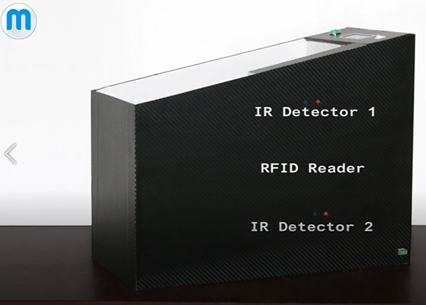Mepits Company has innovate Smart trolley with IOT. Which is used two IR detectors, RFID Reader, Micro controller, Bluetooth module, Bill Button, LCD Display, Power Switch, RFID tags and 12V Battery. This will process like this. When Product adding IR detectors will conform the products added or removed. There are unique RFID tags. Then, RFID readers detect the RFID tag products and then send Product name and price to LCD Display. In this system same product can add multiple times and can remove any products. After, shopping completed then press the Bill button then, Bill which meant total price with product details send to mobile application by Bluetooth. There is a power supply by 12V battery.

**(Figure 1- This is a Figure of RFID Reader and IR Detectors)**

**IOT-** When Bill button press its sends the whole total price with product details send to mobile application via Bluetooth. So, this trolley and mobile Application is connected with each other by Bluetooth network.

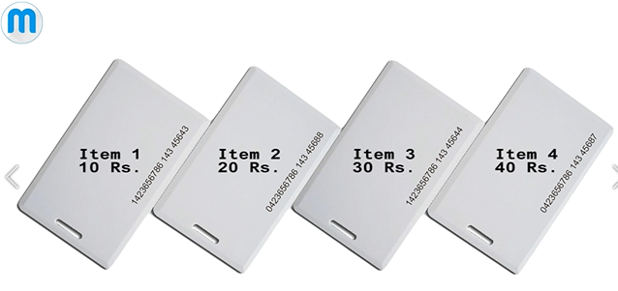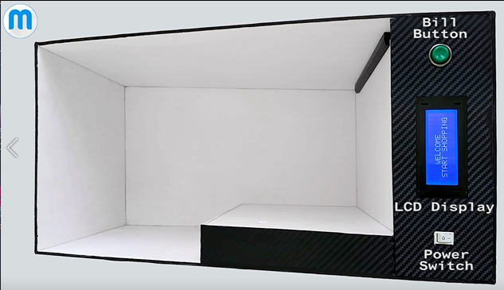

**(Figure 3- This is a Figure of RFID tags)**

**(Figure 2- This is a Figure of Bill Button, LCD Display and Power Switch)**

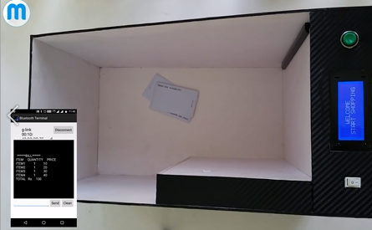

**(Figure 4- This is a Figure of Mobile application output when we press the bill button)**

**(www.youtube.com/watch?v=EgUB0mW6zRc&t=2s, n.d.)**

### SATHI (PERSONAL ASSISTANT)

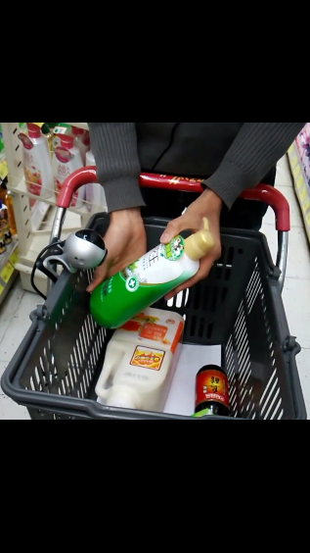This is a personal assistance that will guide to buy things in supermarket. It guide us in voice cut. There is a scanner and hand phone in supermarket trolley. So, if we choose any item in supermarket then we must scan that item from scanner. Then that SATHI will provides all the necessary information about that product though its voice system in our own language. Such as price, expiry date, country of manufacture, how to use it and valid offer and many more. Every customer has unique account in the supermarket. That SATHI is a server computer. This is a personal assistance.

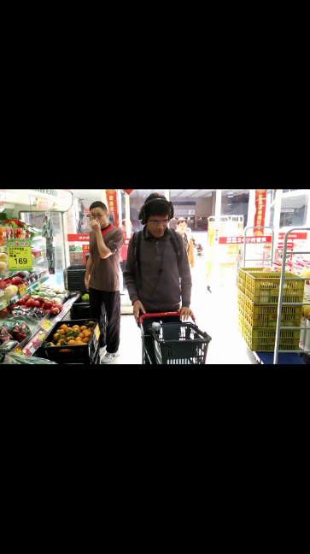**When customer enter the supermarket sensors in supermarket identify them and according to their account they will guide by personal assistance.**

**(Figure 5- This is a Figure of scanner scanning a Product)**

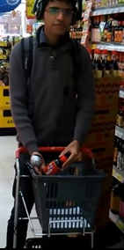**IOT-** scanner and personal assistance is connected with internet and share the information. Input from scanning output from voice. After bought items that personal assistant is connected with bank. All the Payment done in credit card.

**AI**- analysing last shopping’s and remembering the products. If the item expiry date meant it will inform. From the **unique identification** that AI know that customer’s gender. If the customer choose any product not related (if customer is male, if he selected the products female or baby products meant) it will inform. Analyse last shopping’s budgets and it will automatically inform about current budget status (if budget is overrun than last shopping’s that will inform). Finally after whole analysing that will inform special offers, discounts and upcoming customer interested products.

**(Figure 6- This is a Figure of Trolley with Scanner and headphone)**

**(Figure 7- This is a Figure of Personal Assistance inform about details of scanning product through the headphone)**

**(www.youtube.com/watch?v=jfzmetXKJs4&t=49s, n.d.)**

### iCart (The Smart Shopping Cart)

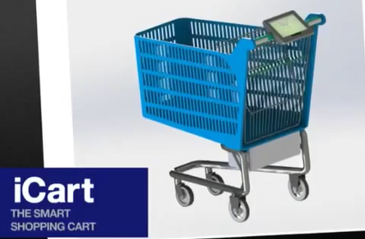iCart smart shopping cart is a company which introduces to market smart trolley. This smart trolley is an electric, comfortable, user friendly and can fast shopping. This smart trolley shopping speed is 252km/h, Autonomy is 8 hours and weight is 72kg. This base is made of Steel AISI 304 and basket is made of Polypropylene 30% Glass fibber. Powered by Electric motor, Wheel hub motor and FG-R-88. Power is 200W, Torque is 5,3Nm and 24-36 VDC/ 8” – 6”. There is a Drive and Control system. That will guide customer to turn right, turn left and go straight. This trollies use Battery system; they are Lead acid batteries and vision battery. This Autonomy is 8 hours, Voltage 24V/ Capacity 24 Ah and 576Wh. There is a charging system and after shopping there is a pay money method call Pay Pass.

**(Figure 8- This is a Figure of iCart shopping smart Cart)**

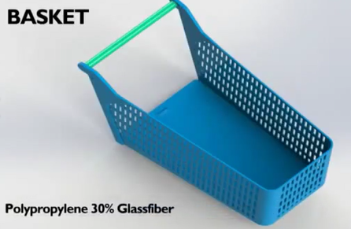This trolley screen there is we have to type our username and password. Then, we will login to our account from screen. There is a server computer. This store every customer accounts and details. After that server computer will analyse our previous shopping and guide us what we have to buy through the screen. After shopping we can pay money from Pay Pass. There are two RFID readers in two sides. Then, trolley is middle. That trolley products will scan by RFID readers and that every information will send to that machine. From the card payment we can pay our amount.

**(Figure 9- This is a Figure of iCart’s Basket)**

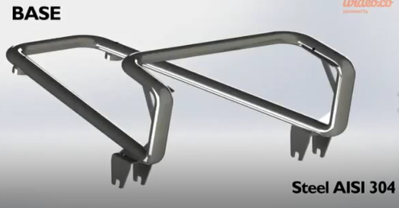**IOT-** iCart screen and server computer is connected via network. When every shopping complete that trolley is scan by both side RFID readers. From that every products details in trolley and total amount is send to that machine. Machine is connected to bank. We must pay our payment throught the card.

**AI-** Server computer has AI and that will analyse our previous shopping and guide us what we have to buy through the screen.

**(Figure 10- This is a Figure of iCart’s base)**

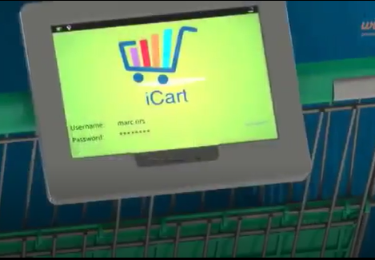

**(Figure 11- This is a Figure of iCart’s screen login page that meant with username and password)**

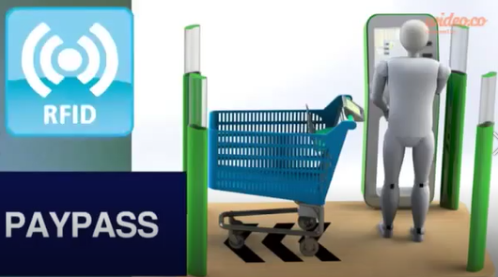

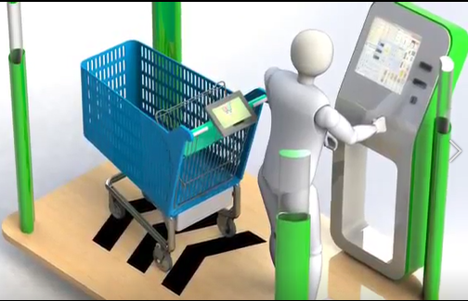

**(Figure 13- This is a Figure of iCart after completing the shopping paying card payment)**

**(Figure 12- This is a Figure of iCart after completing shopping that RFID readers will scan the trolley and send the details to that machine. From this machine customer pay their payment by card.)**

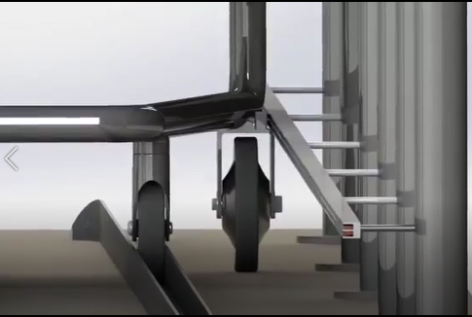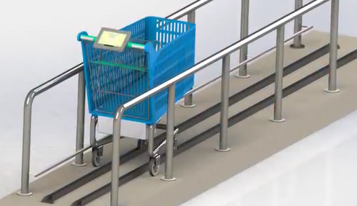

**(Figure 15- This is a Figure of iCart powered by charging through the wheel)**

**(Figure 14- This is a Figure of iCart powered by charging)**

**(www.youtube.com/watch?v=40oH-dhtIK0&t=2s, n.d.)**

### AMAZON GO

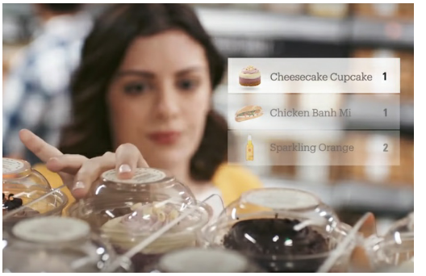When entering to amazon go supermarket that entrance is checking and verifying our QR code and permitting us. So, that QR is in a mobile application and we must have account in there. After that we can shopping well. When we pick up any things that will be automatically added to our virtual card. That shopping will update for our virtual card automatically. They used computer vision, deep learning algorithms, sensor fusion like just walk out technology. When we leaving the supermarket we don’t need to wait to pay money. Every items which we took they will update in our virtual card. And we can check it in our amazon go account in our mobile application. So, our payment done through our credit card. They used camera tracking system that also uses AI in the form of the facial recognition or user biometrics, as well as sensors. This is would work using a system of cameras, sensors and / or RFID readers to identify shoppers and their items.

**(Figure 16- This is a Figure of updates of virtual card)**

**QR code**- to the entrance unique QR code (Primary key) for every account (in mobile app)

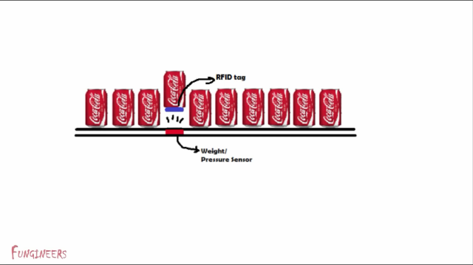**IOT**- Supermarket sensors and virtual card connected with network and exchanging information.

**AI**- if we took anything that will be automatically updated. If we took any item and we kept it meant that will be also automatically updated. That buying items can be change by human to human. And finally AI conform we took that items or not. They use Deep learning algorithms and just walk out technology meant that must be an Artificial Intelligence.

**(Figure 17- This is a Figure of uses of weight sensors and RFID tag in shelves)**

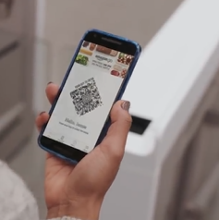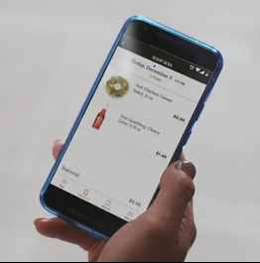

**(Figure 18- This is a Figure of QR for Amazon Supermarket Entrance)**

**(Figure 19- This is a Figure of Mobile App with All the details of products which they bought)**

**(www.youtube.com/watch?v=NrmMk1Myrxc&t=36s, n.d.)**

### indolytics technology

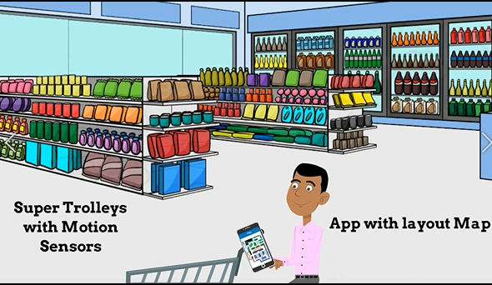indolytics technology provides mobile application, super trolley and main server computer. Main server computer which gives all activities happening in the store and giving the admin to all the control. This is work like this. The customer walks in. pick up a super trolley. The trolley is always with motion sensors. Using their mobile app customer will navigate the products which they have to buy. Main server computer keep tracks through the trolley’s motion sensors. Where customer will go, how long customer will stop and which section customer buy from and quae wait time at the payment time. This main computer can control the Contextual discount as a customer crosses varies sections. This main server can actually track all the activities using with digital and cloud based interactive map.

**(Figure 20- This is a Figure of super trolley and Mobile app with layout Map)**

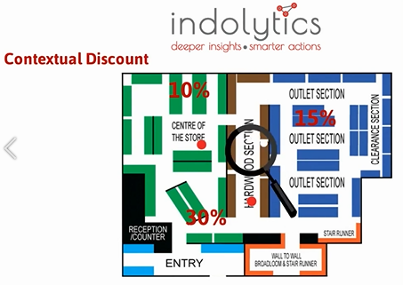

**IOT-** indolytics technology provides mobile application, super trolley and main server computer. So, these are connect each other in cloud base.

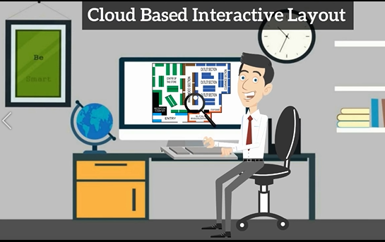

**(Figure 21- This is a Figure of server computer guides that trolley cross the products in various section according to discount Products)**

**(Figure 22- This is a Figure of server computer tracks all the activities happening in the supermarket)**

**(www.youtube.com/watch?v=psPg3cgQYdc&t=22s, n.d.)**

### Modern-Expo Group (Self-Checkout on the Go (Smart Shopping Cart))

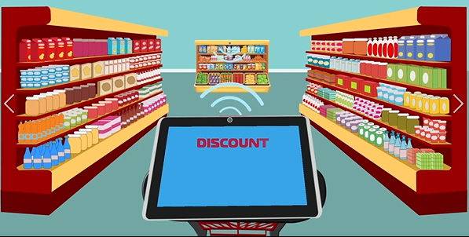This is a smart trolley. This has one screen. That screen displays main details of products and navigate the products. Every shelves there have sensors. That sensors will send products discount by network. When smart trolley go near to those sensor; trolley screen and those sensors will connect each other by network. So, that sensors sends discount products details and that screen will display those information.

**(Figure 23- This is a Figure of Screen of Smart trolley is connecting with shelf sensors by go near shelves)**

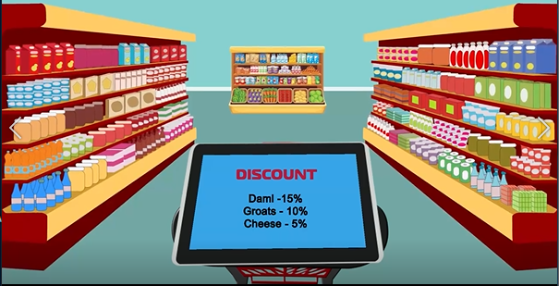This screen is connected to mobile app also from the network. So, this mobile application will remind what the products we have to buy. Then, that screen navigate those products places. In trolley there is a reader of products. Then, if we add any products that will scan and sends the details to screen. The details are product image, quantity, cost and total price. So, finally screen will show whole products total price with those details and after that when we go near to counter that products details will send to counter computer by network before we reach the counter.

**IOT-** This Screen Connected to shelves sensors by network. Mobile App will remind customers to products which they have to buy. According to those products Screen of Cart will navigate products places. After shopping before customer reach the counter Screen will send all the products and total to counter computer. This is also connected with network.

**(Figure 24- This is a Figure of Screen of Smart trolley which displays all the discount products in nearest shelves)**

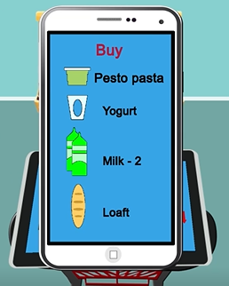**AI-** Mobile Application Analyse what we always buying products and remembering the products.

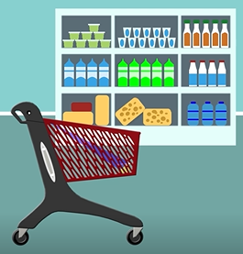

**(Figure 25- This is a Figure of Mobile app remembering the products)**

**(Figure 26- This is a Figure of trolley which scans the products when we adding to trolley)**

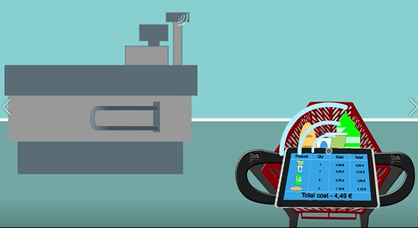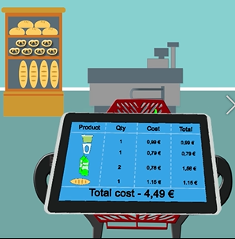

**(Figure 27- This is a Figure of trolley screen which displays products details which we add to trolley)**

**(Figure 28- This is a Figure of trolley screen connected to counter computer through the network. That will send the product details before trolley reach to counter)**

**(www.youtube.com/watch?v=VaVRTBB2LVM&t=6s, n.d.)**

### Flavio Bernardo

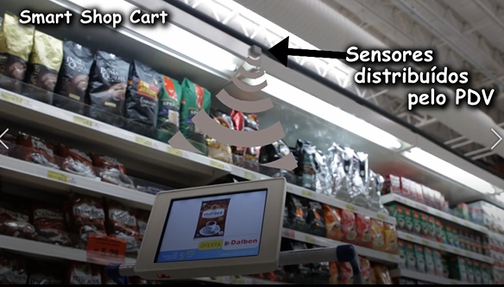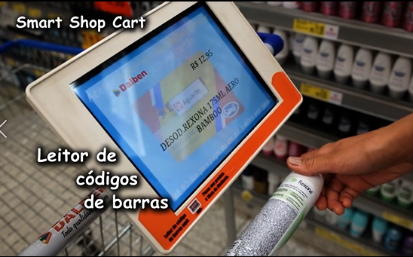This company also introducing smart trolley for supermarkets. So, this trolley has large display. So, in this display we can see all the information about discount products and scanning products. There is a barcode reader side of screen. So, we can scan products by barcode from barcode reader. Then, we can see in the display all the main information about products and we can add in to trolley. Every each shelf has sensors to inform about products discounts. It sends the discount products details through the network. When the trolley is near to that sensors that display will automatically get the information about discount products and display in the screen. So, they will get alert from those sensors.

**(Figure 29- This is a Figure of Trolley Screen scanning the products from barcode of products)**

**IOT-** Sensors and trolley screen connected and share information about discount by network.

**(Figure 30- This is a Figure of Trolley Screen get signal from sensors about discount product when trolley goes near to shelf)**

**(www.youtube.com/watch?v=OeSqnLZXKM4&t=4s, n.d.)**

### Grocer Augmented Shopping (European Project)

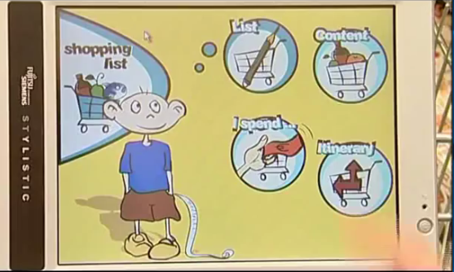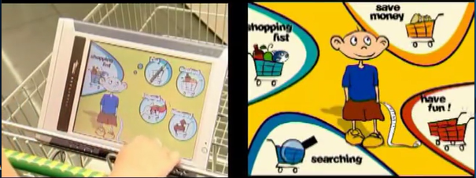In here they use smart trolley. In this trolley there is a touch large screen in the trolley. When customer enter to the supermarket that customer will register with the system and identify themself. System will use to store data with the complete personal service to enjoy the all the benefits of user. When customer start the shopping; trolley screen will show main menu which contains shopping list, save money, have fun and searching. In shopping list service artificial intelligence software will use to help customers in their shopping. In there is list. It reminding products which user forget to buy by analysing the last shopping’s. In content contain basic products list. That will store every time customer consume products list. Customer can add or delete any products in that list. So, that will store in database. In Ispend customers can know what products are in trolley and how much they have to spend for that. Then they can know expenditure of money. Itinary is a three dimensional map. This will guide the customer the shortest way/ distance to reach the selective product.

**(Figure 31- This is a Figure of** **main menu in trolley screen which contains shopping list, save money, have fun and searching)**

**(Figure 32- This is a Figure of** **submenu of shopping list in trolley screen which contains list, content, Ispend and Itinary)**

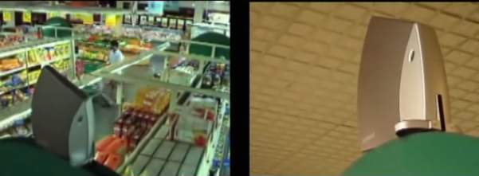This technology Allows to system to localized the customer details and send them information every movement. This is based localization technology and intelligent software send to the system personalized messages at the right time and right customer. Save money service allows the customer offers, promotions and points in interactive ways. This will pop up messages near to offer or discount products. Or in icons colours of those icons will change. Privacy protected by customer preferences. In searching we can see all the information and ingredients of which we selecting product by scan the barcode reader.

**(Figure 33- This is a Figure of sensor technology this will send to the system personalized messages at the right time and right customer)**

**IOT-** trolley screen, main computer which customer data stored and sensors are connected with each other in a network and communicate and share information via network. Customer can track their friend’s location inside the supermarket and they can chat with each other in text massages. So, this is also act like communication device via network.

**AI-** every customer has account in main computer. The computer uses AI to remember the product list from previous analysing shopping. Then, Show the shortest way route to reach those products. That analysing all expenditures and comparing then shopping and reminding. Every each user points and promotions are different. That Computer those data and give correct amount of them to each customers.

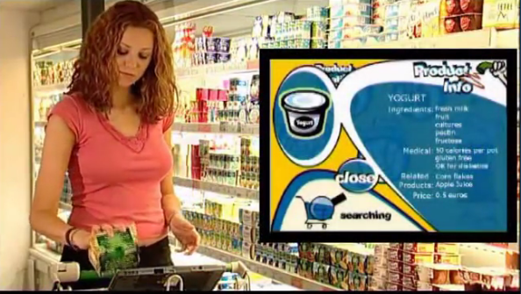

**(Figure 34- This is a Figure of trolley screen product information by customer scan that product barcode to barcode reader)**

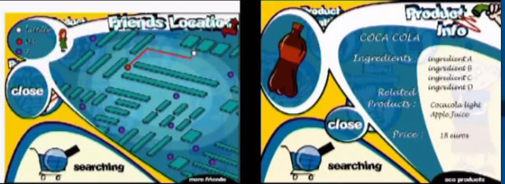

**(Figure 35- This is a Figure of** **submenu of Searching in trolley screen which includes friends’ location searching in supermarket and search products details by scanning)**

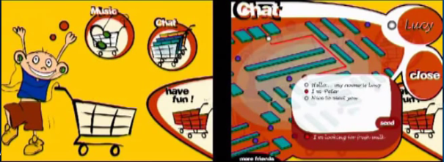

**(Figure 36- This is a Figure of** **submenu of Have fun in trolley screen which includes chat with supermarket friends and can hear the music)**

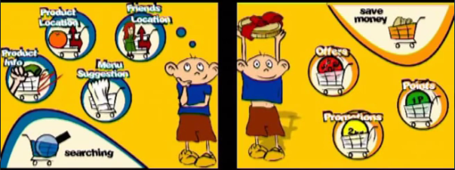

**(Figure 37- This is a Figure of** **submenu of Searching in trolley screen which includes friend’s location, Menu suggestions, Product info and product location)**



**(Figure 38- This is a Figure of** **submenu of save money in trolley screen which includes offers, promotions and points)**

**(www.youtube.com/watch?v=KdT4miCTbds, n.d.)**

## Research approach and methodologies

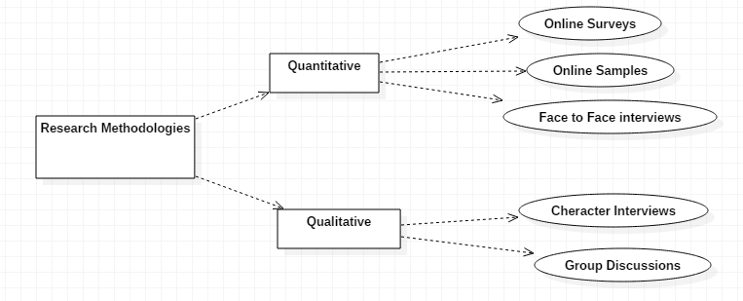

**(Figure 39- This is a Figure of some of** **methodologies of research)**

### Quantitative research methods

Quantitative Research is used to quantify the problem by using way of producing numerical data or records that can be changed into usable statistics. It is used to quantify attitudes, opinions, behaviours, and different defined variables – and generalize consequences from a large pattern population. Quantitative Research uses measurable records to formulate statistics and uncover patterns in research. Quantitative statistics series methods are a lot more structured than Qualitative facts collection methods. In here we can divide it in three ways. They are online surveys, online samples and ace to face interviews. But, in this project I used three methodologies in quantitative research methodologies. They are online surveys, online samples and face to face interviews. In online samples meant we get the information from internet. So I collect lots of information of this project from internet, YouTube. From Internet meant use of personal records, data analysis and action research. Face to face interview for this project is I Interviewed our lecturer and got lots of ideas for this projects and got ideas from seniors also. For online surveys I used Google forms and got 260 responses from people which I know well. So, I will detailed below about online surveys (Author’s view).

#### Online surveys

I created online surveys in Google form and got two hundred sixty responses (260). From this I can get some decisions for my project.

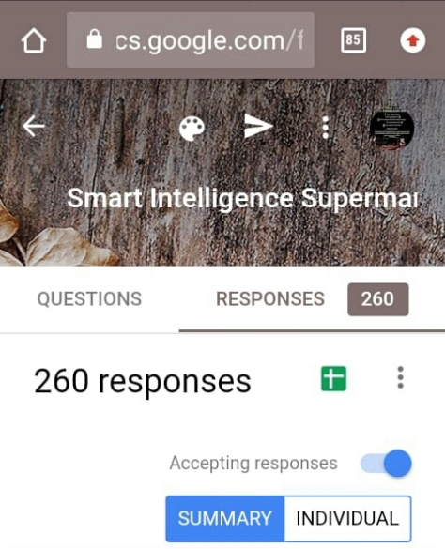

**(Figure 40- This is a Figure of online Google form responses which I got from people I known for my Project)**

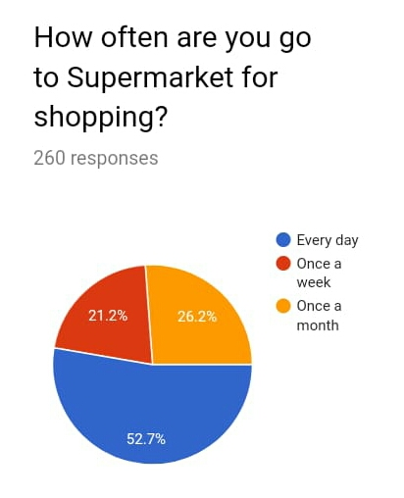First question which I asked in my questionnaire is about status of shopping period in supermarket from people which I known.

From these two hundred sixty responses (260) fifty two point seven percentage of people go to shopping every day. Twenty six point two percentage of people go to shopping once a month. Twenty one point two percentage of people go to shopping once a week. So, from this information we can get main decision which is this era is changing Supermarket Shopping is main need for every people. So, if we focus any projects related to supermarket mostly that will be success.

**(Figure 41- This is a Figure of online Google form responses which for percentage status of supermarket shopping)**

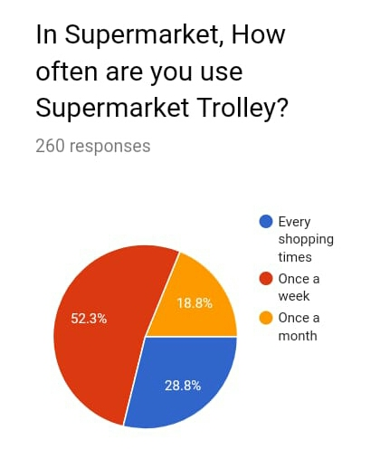

From those people the status of people percentage which they use supermarket trolley or shopping. Fifty two point three percentage use once a week supermarket trolley. Twenty eight point eight percentage use supermarket trolley in every shopping times. Eighteen point eight percentage use supermarket trolley in once a month. From these information most of people are every day shopping. Among them most of them use shopping trolley once a week. Quarter percentage use shopping trolley every shopping times.

**(Figure 42- This is a Figure of online Google form responses which is percentage status for usage of supermarket Trolley)**

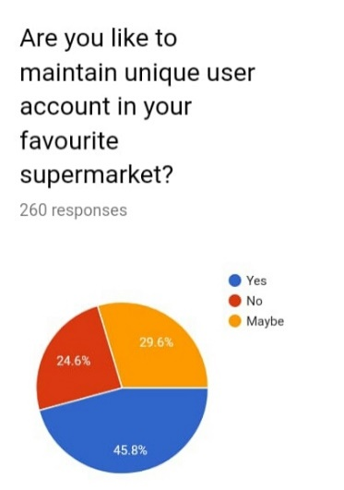From these people forty five point eight percentage will surely prefer to maintain unique user account in favorite supermarket. Twenty nine point six parentage people not sure to maintain unique account in supermarket. Twenty four point six parentage people not interested in unique account in supermarket. From this information almost everyone like to maintain unique user account in supermarket. From this we can connect trolley screen to user account and get previous details of shopping through that we can get guidance for shopping.

**(Figure 43- This is a Figure of online Google form responses which is percentage status of preference to maintain unique account in supermarket)**

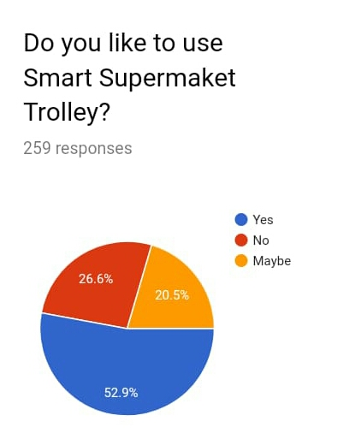

Fifty two point nine percentage like to use smart supermarket trolley. Twenty six point six percentage not like to use smart supermarket trolley. Twenty point five percentage no sure idea to use smart supermarket trolley. Among these almost everyone like to use smart supermarket trolley. So, from this information our project has demand and it can be almost success in market.

**(Figure 44- This is a Figure of online Google form responses which is percentage status of preference to use smart supermarket trolley)**

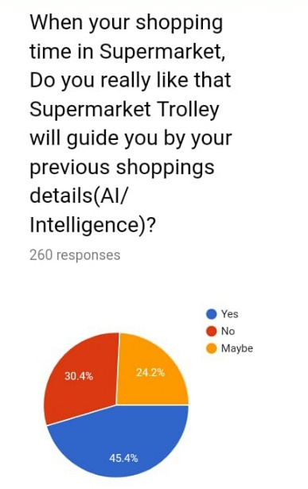

Forty five point four percentage will prefer to use supermarket trolley which will guide customer by their previous shopping details. That meant using Artificial Intelligence (AI). Thirty point four percentage not prefer to use supermarket trolley and twenty four point two percentage no sure idea to use supermarket trolley which will guide customer by their previous shopping details. Among these people Almost everyone interested to use AI. From these Information if we include AI in our project meant that will be most successful.

**(Figure 45- This is a Figure of online Google form responses which is percentage status of preference to use AI for smart supermarket trolley)**

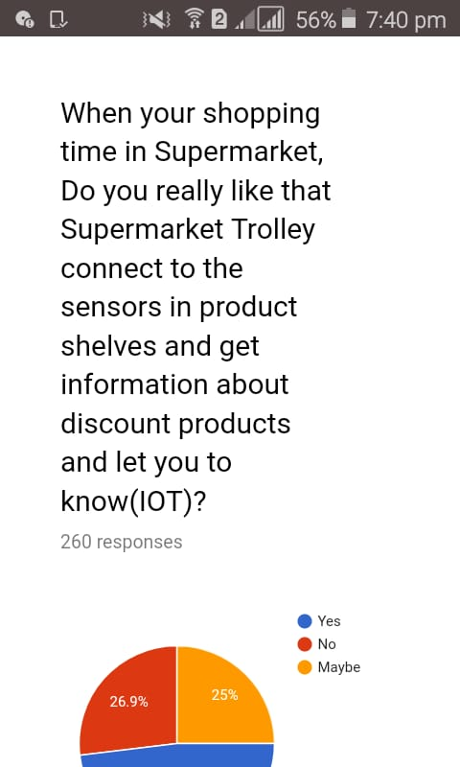

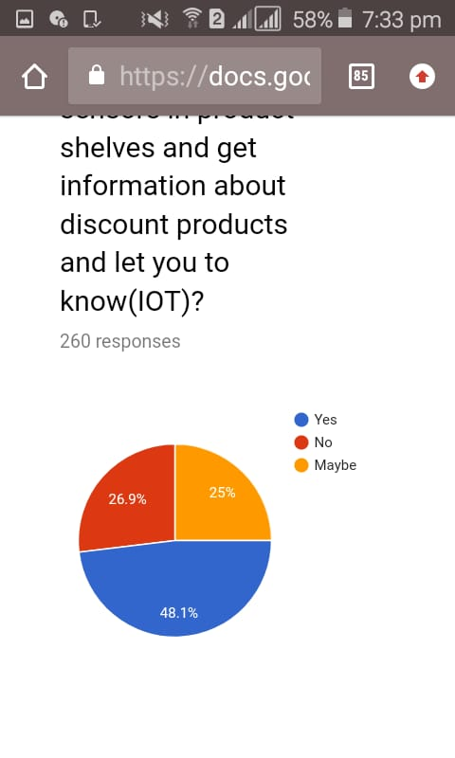Forty eight point one percentage prefer to use supermarket trolley that connect to sensors in product shelves and get information about discount products and let customer to know. That meant trolley and those sensors connect with network. So, that is call as IOT. Twenty six point nine percentage not prefer to use IOT. Twenty five percentage no sure idea to use IOT. From these information almost everyone interested to use IOT. So, in my project also I will include IOT.

**(Figure 46- This is a Figure is a question which is to know percentage of prefer to use IOT)**

**(Figure 47- This is a Figure of online Google form responses which is percentage status of preference to use IOT for smart supermarket trolley)**

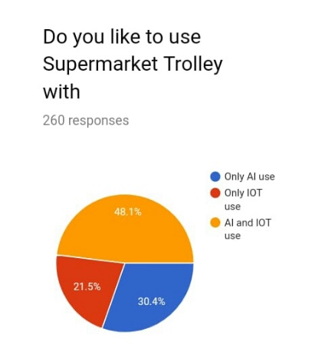

Forty eight point one percentage prefer to use supermarket trolley with AI and IOT. Thirty point four percentage prefer to use Only AI only. Twenty one point five percentage prefer to use supermarket trolley with IOT only. Most of them prefer to have AI and IOT based Supermarket Trolley. So, In my project also I will do AI and IOT based Supermarket Trolley.

**(Figure 48- This is a Figure of online Google form responses which is percentage status of preference to use IOT and AI for smart supermarket trolley)**

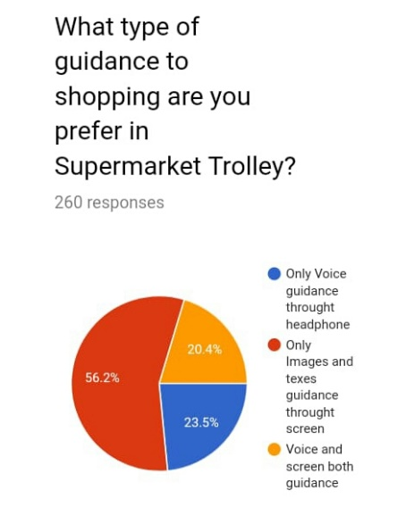

Fifty six point two percentage will prefer to use Supermarket Trolley with images and texts through the screen guidance only. Twenty three point three percentage prefer to use Supermarket Trolley voice guidance through the headphone. Twenty point four percentage to use Supermarket Trolley with screen and voice both guidance. If we use voice system to guidance meant that will be sound effect for supermarket environment and hard to remember those details through voice but if we use screen we can see guidance from screen then we can easily remember those information. Supermarket environment also no hassle. In here most of them prefer to use screen guidance. So, we also use screen guidance to our project.

**(Figure 49- This is a Figure of online Google form responses for Voice and screen guidance for smart supermarket trolley)**

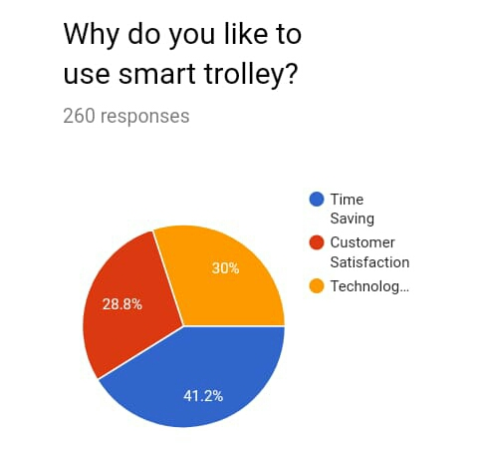Forty one point two percentage prefer to use smart trolley for time saving purpose. Thirty percentage prefer to use smart trolley for technological use. Twenty eight point eight percentage prefer to use smart trolley for customer satisfaction purpose. Almost, everyone prefer to use this trolley for time saving purpose.

**(Figure 50- This is a Figure of online Google form responses for reasons of prefer to use smart supermarket trolley)**

**(Author’s view)**

### Qualitative research methods

Qualitative Research is exceptionally investigative research. It is used to obtain an understanding of underlying reasons, opinions, and motivations. It affords insights into the trouble or helps to advance thoughts or hypotheses for manageable quantitative research. Qualitative Research is additionally used to discover traits in notion and opinions, and dive deeper into the problem. Qualitative information series methods change using unstructured or semi-structured techniques. Some common techniques include focal point organizations (group discussions), character interviews, and participation/observations. I choose character interview as qualitative methodology. I selected one person know about smart trolley and I interviewed him. Again, for this also I interviewed Mr. Anis Saboordeen lecturer of this project and got lots of ideas (Author’s view).

## Artefact (proposed)

There is a large screen on the top of trolley. When customer enter to supermarket then, they just login to the system via screen. Every products have RFID tags. If we add any products to the trolley those products detect by RFID readers and send the details of products to display. Such as image and the name of products, price of products, quantity of products and total price of products. Every products which we add for purchase whole details should display in the screen. When we are adding and removing products will conform by IR sensors. We will use Power Adapter to power supply (Author’s view).

There are shelves with sensors. This is send information about that shelf contain discount products. When we are crossing those shelves those sensors connected with our trolley screen via network. So, those information of discount products will get as pop up messages in the trolley screen. When we are selecting the products which for buy we can know exact price of those products. And we can reduce our shopping expenditure. In here this system is run in main computer. That computer stores every each customer data. There is a counter computer in supermarket. After finish our shopping; trolley screen will sends the information about products details of purchase before we reaches the counter. So, counter computer and our screen is connected with each other in network. Then, we don’t need to wait for queue. We know about our total price before the cashier knows the total price. So, we can easily ready our payment by card or money (Author’s view).

**AI-** When we are shopping time system will analyse last shopping’s and remembering the products which we like to buy. If the products is expiry meant system will inform us. If the customer is male meant if he select any item from female or baby that will inform to customer. Analyse the previous shopping’s budget and remembering the budget if the budget is overrun meant. When customer shopping time system will send the special offer, discounts and points messages. Then, screen will navigate those products places. That system will inform upcoming products which customer like and purchasing most. So, these information will display in display (Author’s view).

**IOT-** trolley screen is connected with System main computer, Shelf sensors and Counter computer and transfer data through the network (Author’s view).

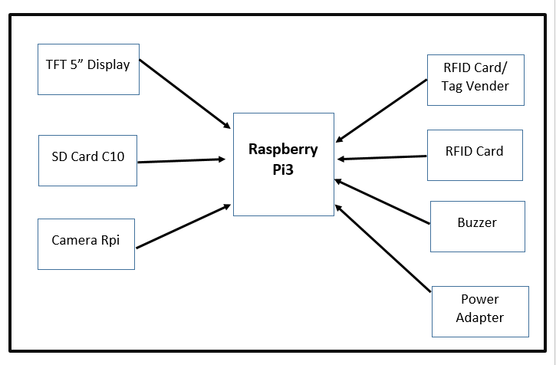

**(Figure 51- This is a Figure of Block diagram)**

## Tools and Techniques:

### Tools

* TFT 5” Display
* Power Adapter
* Trolley Unit
* Camera Rpi
* SD Card C10
* Wireless Networking
* AI Software (Tensor flow)
* Raspery pi3
* RFID Card/ Tag Vender / IR sensor
* RFID 125MHz Card
* Project Box Medium
* Buzzer

### Techniques

* Agile development method (Scrum)
* Factory Design Pattern

(Author’s view)

## Plan/Schedule

### Gantt chart

**(Figure 52- This is a Figure of Gantt chart)**

### Work break structure

**(Figure 53- This is a Figure of Work Break Structure of Initiating and Planning Phase)**

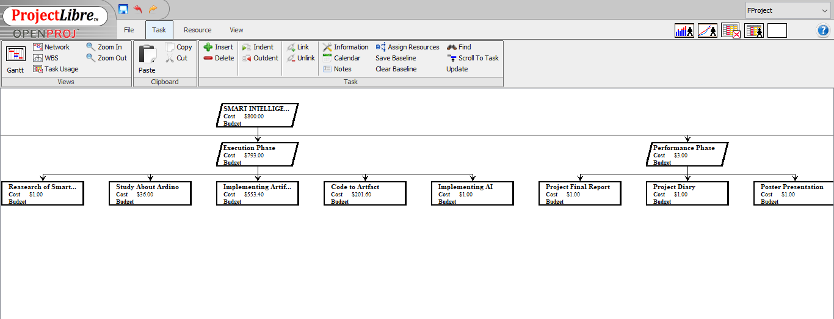

**(Figure 54- This is a Figure of Work Break Structure of Execution and Performance Phase)**

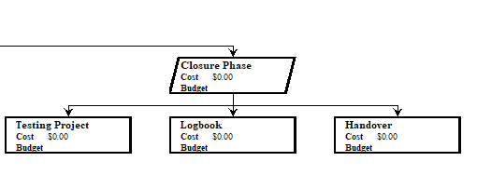

**(Figure 55- This is a Figure of Work Break Structure of Closure Phase)**

### Active network diagram

**(Figure 56- This is a Figure of Active network diagram)**

### Time plan with Resources

**(Figure 57- This is a Figure of Time plan with Resources)**

## Cost Analysis

|  |  |  |
| --- | --- | --- |
| **Products name** | **Price** | **Quantity** |
| Raspery pi3 | $35 | 1 |
| TFT 5” Display | $ 79 | 1 |
| SD Card C10 | $10 | 1 |
| Power Adapter | $0.5 | 1 |
| Camera Rpi | $29 | 1 |
| RFID Card/ Tag Vender | $39 | 1 |
| RFID 125MHz Card | $8.00 | 10 |
| Project Box Medium | $0.8 | 1 |
| Buzzer | $0.1 | 1 |
| **Total Price** | $201 |  |

(www.adafruit.com, n.d.)

## References and Bibliography

* link.springer.com, n.d. *link.springer.com.* [Online]   
  Available at: https://link.springer.com/chapter/10.1007/978-981-10-9059-2_33  
  [Accessed 28 01 2019].
* www.adafruit.com, n.d. *www.adafruit.com.* [Online]   
  Available at: https://www.adafruit.com/?q=power  
  [Accessed 28 1 2019].
* www.ijraset.com, n.d. *www.ijraset.com.* [Online]   
  Available at: https://www.ijraset.com/fileserve.php?FID=10615  
  [Accessed 28 01 2019].
* *www.youtube.com/watch?v=40oH-dhtIK0&t=2s.* n.d. [Film] s.l.: s.n.
* *www.youtube.com/watch?v=40oH-dhtIK0.* n.d. [Film] Directed by www.youtube.com/watch?v=40oH-dhtIK0. s.l.: www.youtube.com/watch?v=40oH-dhtIK0.
* *www.youtube.com/watch?v=EgUB0mW6zRc&t=2s.* n.d. [Film] Directed by www.youtube.com/watch?v=EgUB0mW6zRc&t=2s. s.l.: www.youtube.com/watch?v=EgUB0mW6zRc&t=2s.
* *www.youtube.com/watch?v=jfzmetXKJs4&t=49s.* n.d. [Film] s.l.: s.n.
* *www.youtube.com/watch?v=jfzmetXKJs4&t=52s.* n.d. [Film] Directed by www.youtube.com/watch?v=jfzmetXKJs4&t=52s. s.l.: www.youtube.com/watch?v=jfzmetXKJs4&t=52s.
* *www.youtube.com/watch?v=KdT4miCTbds.* n.d. [Film] Directed by www.youtube.com/watch?v=KdT4miCTbds. s.l.: www.youtube.com/watch?v=KdT4miCTbds.
* *www.youtube.com/watch?v=NrmMk1Myrxc&t=36s.* n.d. [Film] Directed by www.youtube.com/watch?v=NrmMk1Myrxc&t=36s. s.l.: www.youtube.com/watch?v=NrmMk1Myrxc&t=36s.
* *www.youtube.com/watch?v=OeSqnLZXKM4&t=3s.* n.d. [Film] Directed by www.youtube.com/watch?v=OeSqnLZXKM4&t=3s. s.l.: www.youtube.com/watch?v=OeSqnLZXKM4&t=3s.
* *www.youtube.com/watch?v=OeSqnLZXKM4&t=4s.* n.d. [Film] s.l.: s.n.
* *www.youtube.com/watch?v=psPg3cgQYdc&t=22s.* n.d. [Film] Directed by www.youtube.com/watch?v=psPg3cgQYdc&t=22s. s.l.: www.youtube.com/watch?v=psPg3cgQYdc&t=22s.
* *www.youtube.com/watch?v=VaVRTBB2LVM&t=6s.* n.d. [Film] Directed by www.youtube.com/watch?v=VaVRTBB2LVM&t=6s. s.l.: www.youtube.com/watch?v=VaVRTBB2LVM&t=6s.

# Research Ethics Approval Form

All students conducting research activity that involves human participants or the use of data collected from human participants are required to gain ethical approval before commencing their research. Please answer all relevant questions and note that your form may be returned if incomplete.

For further support and guidance please see your respective Unit Tutor.

**Before completing this form, we advise that you discuss your proposed research fully with your Unit Tutor. Please complete this form in good time before your research project is due to commence.**